**Present work:**

Refraction of light depends on the refractive indices of two mediums, one from where the light ray is coming and another from where it is getting reflected. We are using the method of refraction to distinguish different numerals because each numeral has different slopes at different sections, so, due to refraction deviation will also differ and thus, we can recognise different numerals.

**Feature using refraction of light rays coming from a point source:**

Light rays are beamed on the numeral from four vertices of the image making angle with the adjacent boundaries with an interval of 5°, making the number of light rays from each corner = 19. Thus the (as light rays are beamed from all the four corners). The image is divided into two halves, the upper part is considered to be filled with air( **µ1 = 1**) and the lower half is filled with a denser medium. The refractive index of the denser medium is **µ2 = 1.5** and is of depth **d**(≤*image size*).. The numeral is also considered to be as a denser medium with refractive index **µ3 = 2**. The refraction in medium 3, i.e the medium of the numeral is considered as glass slab refraction. Thus the light rays will suffer at least one refraction and at most two depending on the values of **d** and the slope of the numeral at that slope.

There can be two types of refractions, one due to the medium 2, i.e the normal refraction and another is due to medium 3, i.e the glass slab refraction. We are considering the second refraction as glass slab due to the fact that the section of the numeral is considered to have parallel surfaces.

The light rays can go through three types of processes:

1. Some light rays will undergo both the refractions. But the light rays with angle of incidence close to 85° will suffer only glass slab refraction (i.e the refraction due to medium 3). Those light rays will not suffer the first refraction, i.e. the normal one. So, for them we will calculate the horizontal deviation only and that will be the final deviation for them.

1. Those light rays which will encounter both of the denser mediums, after entering the second medium the light ray will suffer normal refraction and then that refracted ray will strike thenumeral (medium 3) and will again undergo through glass slab refraction. The final horizontal deviation (displacement is taken, i.e. it can be both negative and positive) is considered as the feature. For glass slab refraction in third medium,

where ,

and .

(3)Only a few light rays, i.e one or two light rays close to 90° will suffer no refraction,i.e they will traverse just a straight line with no deviation and so,

To get the horizontal deviations, help of the above mentioned formulae has been taken. For each kind of refraction, first the data pixel, on which the light ray is striking has been found out and then deviation at that section is calculated taking the help of local slope and local width. Then if further refractions are possible, the method is carried out in the same manner.

**Feature using refraction of a beam of parallel light rays:**

A parallel beam of light rays is thrown on the numeral from the top of the image. The numeral here acts as denser medium with refractive index **µ2 = 1.5** and that of the background is same as that of air, i.e **µ1 = 1**. At first the data pixels where the light rays strike in first place are found out. Here also each small section of the numeral is considered as a glass slab,(i.e it is considered to have same slope or parallel surfaces for each small section) and so the horizontal deviation which we get by glass slab refraction for each ray is taken as our feature. For calculating the horizontal deviation, the local width and local slope are found out and accordingly the lateral shift and horizontal deviation (displacement is considered, i.e we can get both positive and negative values) are calculated using the following equations:

where , and .

**Glass slab refraction:**

We know that light traverses in straight line in a medium or through two mediums with same density. Now we need to see what happens when it travels through mediums of different densities. So, when this happens light ray bends at the boundary between two mediums. This phenomenon of bending of light ray is known as **Refraction of light**. Now when a light ray traverses through a glass slab it suffers a parallel shift or lateral shift after exiting the slab. The first angle of refraction and second angle of refraction are equal as the slab is parallel and so does the angle of incidence and angle of emergence for the same reason.

Lateral displacement is the perpendicular distance between the incident and the emergent rays when the light ray is incident on the slab obliquely.

**Factors on which the lateral displacement depends:**

(1)Lateral displacement is directly proportional to the thickness of the slab.

(2)Lateral displacement is directly proportional to the angle of incidence.

(3)Lateral displacement is directly proportional to the refractive index of the slab.

(4)Lateral displacement is inversely proportional to the wavelength of the incident light ray.

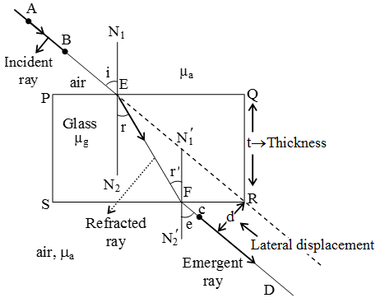

The above image clearly depicts the phenomenon of **glass slab refraction of light**. And the lateral displacement as shown in the figure can be expressed as,

**Local slope and width calculation:**

For both of the above mentioned methods, local slope and local width have been calculated in the following way.

For slope calculation, the data pixel, on which the light ray first strikes, is found out and taking the horizontal axis as main axis a straight line is rotated from 0°to 360° with an interval of 10° and the corresponding stroke widths are also noted. As we know that perpendicular distance is always minimum, we take the minimum stroke width as our local width and the complementary angle of corresponding angle of rotation is taken as the local slope. Angle of incidence depends on slope.

We have chosen the horizontal deviation as our feature because the deviation will change with slope which will vary from numeral to numeral.